Disciplina | Eng. avaliador
Título do relatório
Primeiro Autor, Segundo Autor, Terceiro Autor
xx de mês de 20yy

Abstract

Resumo daquilo de que trata o relatório para qem quiser saber rapidamente sobre o qe é sem ter q estar a ler tudo.
Palavras-chave: por aqui as palavras que alguém usaria para procurar no google para encontrar este relatório ou que melhor englobam o tema e principais métodos usados.
- Introdução

There is evidence of increasing participation and interest in cycling (Grous, 2011), and a large body of literature exists relating to bicycle technology. Mostly these relate to the common diamond “safety” framed road or mountain bicycles, and wide range of specialist tools are now available to support bicycle development through analysis and iterative improvement. Finite Element Analysis (FEA) has been used to analyse composite, aluminium and steel bicycle frames (Peterson and Londry, 1986; Lessard et al, 1995; Maestrelli and Falsini, 2008; Liu and Wu, 2010; Reynolds Technology Ltd, 2011a) with the aim of understanding physical behaviour and improving performance relating, however a comprehensive study on the influence of key geometric parameters on the stiffness of frames has not been conducted. The aim of this study was to evaluate the influence of key geometric parameters on frame stiffness using a wide range of bicycle frame designs from historical data and to compare these to an optimised solution.
- Revisão Bibliográfica

In imperdiet lorem quis nunc pellentesque commodo. Maecenas porta neque ut turpis porta, vel tempus sem condimentum. Integer dictum in ipsum eu egestas. Cras a dapibus felis. Phasellus blandit mauris non diam dictum egestas. Fusce neque felis, congue ut est quis, tempor varius erat. Phasellus bibendum suscipit quam, id varius lacus hendrerit viverra. Ut scelerisque arcu interdum dui varius, vel tincidunt augue sagittis. Morbi id augue varius est bibendum consectetur a maximus neque. Interdum et malesuada fames ac ante ipsum primis in faucibus. Fusce eleifend luctus enim in dapibus. Curabitur congue sapien ut arcu ultricies hendrerit. Cras eget fermentum ipsum.
- Procedimentos

Donec mattis risus at leo convallis volutpat. Vestibulum a quam vehicula urna pellentesque tincidunt. Duis et convallis tellus, eget aliquet tellus. Nam mattis lacinia nunc in pulvinar. In sit amet vehicula leo. Ut molestie eu metus non consectetur. Aliquam fermentum est vel eleifend mattis.
- Resultados e discussão

Fig. 2 shows example displacement plots for a small frame in both load cases. Table 2 shows the optimised geometry for both load cases and the combined model, and Table 3 shows the displacement values from the range of frames analysed and the optimised results also. The smaller frames (490mm seat tube) behave the most favourably in terms of both vertical compliance and lateral stiffness, while the shorter top tube length (525mm) and larger head tube angle (74.5°) results in a laterally stiffer frame which corresponds with Peterson and Londry (1986) since this combination will result in the shortest down tube which is mostly responsible for supporting lateral loads.

The optimised values show a considerable improvement over the best of the existing frames, with a 13% increase in vertical displacement and 15% decrease in lateral displacement when compared to the best of the analysed frames.
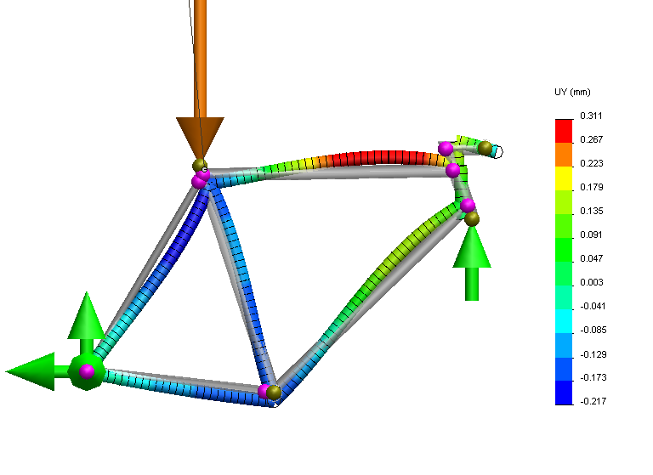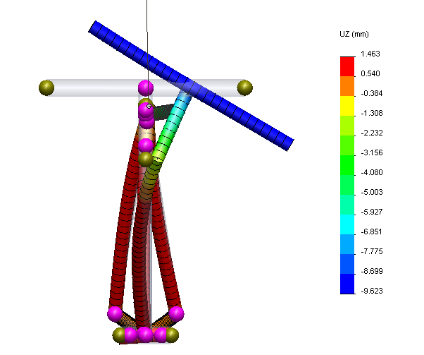

Fig. 2. Legenda de figura
Table 2. Legenda de tabela
 | Maximising vertical displacement (vertical seat tube load) | Minimising lateral displacement (lateral BB/handlebar load) | Optimising both
Seat tube length (mm) | 490 | 490 | 490
Head tube angle (deg) | 71.50° | 74.25° | 74.25°
Rake offset (mm) | 76 | 38 | 80
Seat tube angle (deg) | 74 ° | 72° | 72°
Chain stay length (mm) | 468 | 405 | 405
Wheel base (mm) | 981 | 1100 | 972
Top tube length (mm) | 608 | 525 | 525
BB drop (mm) | 80 | 45 | 45

The seat tube and top tube lengths explain most of the variance in the displacement data and as such contribute the most to the overall stiffness-compliance ratio, but it can be seen that of all the frames tested those smaller frames are still some way short of the theoretical optimum stiffness-compliance ratio of 1.00 for the range of frame geometries analysed.
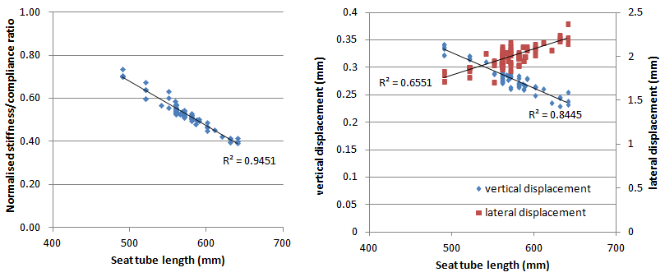
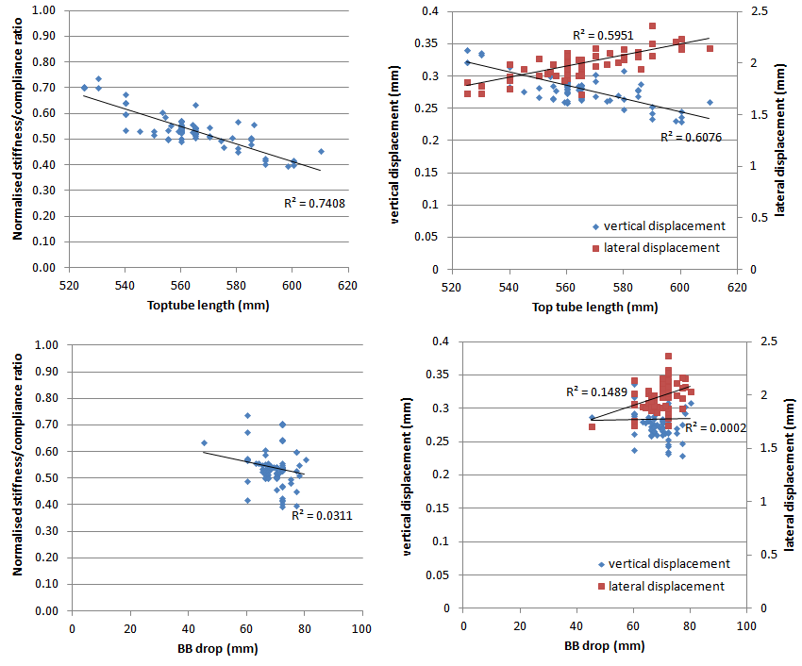

Fig. 3. Gráficos tipo
Conclusões

This paper has outlined a relatively simple FE model using beam elements to represent a standard road bicycle frame. The model simulates two standard loading conditions to understand the vertical compliance and lateral stiffness characteristics of 82 existing bicycle frames from the bicycle geometry project and compares these characteristics to an optimised solution in these conditions. Perhaps unsurprisingly smaller frames (490mm seat tube) behave the most favourably in terms of both vertical compliance and lateral stiffness, while the shorter top tube length (525mm) and larger head tube angle (74.5°) results in a laterally stiffer frame which corresponds with findings from literature. . The optimised values show a considerable improvement over the best of the existing frames, with a 13% increase in vertical displacement and 15% decrease in lateral displacement when compared to the best of the analysed frames. The model has been developed to allow for further develop to include more detailed tube geometry, further analysis of more frame geometries, alternative materials, and analysis of other structural characteristics.

Referências
Ballantine, R. 2000, Richard’s 21st Century Bicycle Book. Pan Books, London.
British Standards. 2005a. Racing bicycles -Safety requirements and test methods. BS EN: 14781- 2005.
British Standards. 2005b. Mountain bicycles -Safety requirements and test methods. BS EN: 14766- 2005.
Burke, E. 1994. Proper fit of the bicycle. Clinics in Sports Medicine, 13(1), 1-14.
Burke, E. 2003. High tech cycling: the science of riding faster” 2nd Ed. Human Kinetics, Leeds, England.
Burrows, M. 2008. Bicycle Design: the search for the perfect machine. Snowbooks Ltd. London, England.

